ZPA Setting (Zero Pressure Accumulation)

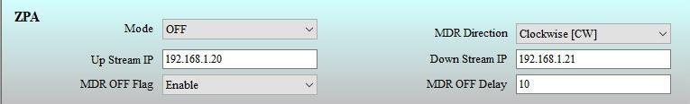
The MDR is an enable condition. If you set 10 sec (MDR OFF DELAY COLUMN), after 10 sec of MDR running automatically the MDR will cut off.
IF Disable condition MDR is run continuously.

 | ZPA Setting (Zero Pressure Accumulation)
Flags |  | State | Description
Mode |  | OFF | ZPA mode Disabled
Mode |  | ON | ZPA mode Enabled, But Other Communication it dose not connect.
Mode |  | Singulation | Bus Mode
Mode |  | GAP Train | Train Mode
MDR Direction |  | Clock wise (CW) | Forward Direction
MDR Direction |  | Counter Clock wise (CCW) | Reverse Direction
UP Stream IP: |  | IP of the First Network | Enter the address
Down Stream IP: |  | IP of the Last Network Card | Enter the address
MDR OFF Flag |  | Enable | When Sensor is Connected
MDR OFF Flag |  | Disable | When Sensor Not Connected
MDR Off Delay |  | Delay time | Delay time in Seconds

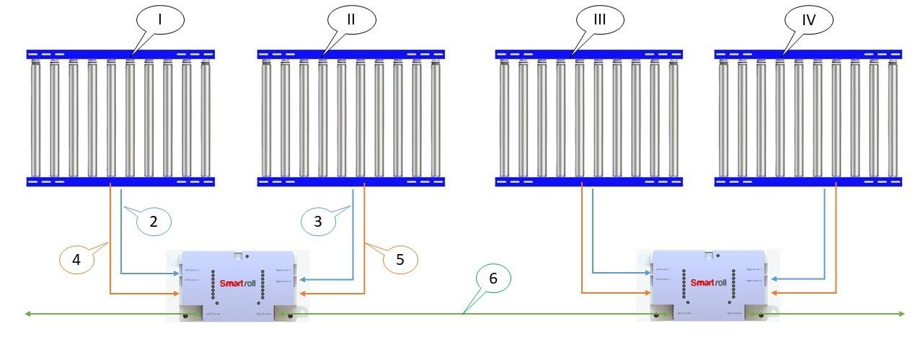

- Module - I, II, III & IV
- Left Sensor Input 1 (Module-1)
- Right Sensor Input 1 (Module-2)
- Left MDR (Module-1)
- Right MDR (Module-2)
- Ethernet communication

Sir, ZPA mode one Smart roll card not working condition.
2 card above Smart roll card ZPA work condition
ZPA mode clack wise conveyor running.
Sensor_1 | Sensor_2 | Sensor_3 | Sensor_4 | Modul_1 | Modul_2 | Modul_3 | Modul_4
0 | 0 | 0 | 0 | 0 | 0 | 0 | 0
1 | 0 | 0 | 0 | 1 | 1 | 0 | 0
0 | 1 | 0 | 0 | 0 | 1 | 1 | 0
0 | 0 | 1 | 0 | 0 | 0 | 1 | 1
0 | 0 | 0 | 1 | 0 | 0 | 0 | 0

ZPA Mode Network Card IP Address Setting :

Expel : 4 Network card series connection ZPA mode clack wise conveyor running.

IP Adress IP Adress IP Adress IP Adress
192.168.250.1 192.168.250.2 192.168.250.3 192.168.250.4
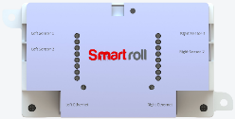

DN Stream IP
192.168.250.4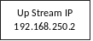

Up Stream IP
192.168.250.3

DN Stream IP
192.168.250.4

Up Stream IP
192.168.250.2

Up Stream IP
192.168.250.1

DN Stream IP
192.168.250.3

Up Stream IP
192.168.250.1

DN Stream IP
192.168.250.2

